Patient Safety Informatics: Meeting the challenges of emerging digital health

Ciarán McInerneya,b, Jonathan Bennb,c, Dawn Dowdingd, Ibrahim Hablie, David Jenkinsd,f, Carolyn McCrorieb, Niels Peekd,f, Rebecca Randellg, Richard Williamsd,f, Owen Johnsona,b

**a** School of Computing, University of Leeds, Leeds, United Kingdom

**b** NIHR Yorkshire and Humber Patient Safety Translational Research Centre, United Kingdom

**c** School of Psychology, University of Leeds, Leeds, United Kingdom

**d** School of Health Sciences, University of Manchester, Manchester, United Kingdom

**e** Department of Computer Sciences, University of York, York, United Kingdom

**f** NIHR Greater Manchester Patient Safety Translational Research Centre, United Kingdom

**g** Faculty of Health Studies, University of Bradford, Bradford, United Kingdom

Abstract

The fourth industrial revolution is based on cyber-physical systems and the connectivity of devices. It is currently unclear what the consequences are for patient safety as existing digital health technologies become ubiquitous with increasing pace and interact in unforeseen ways. In this paper, we present a definition of Patient Safety Informatics that was informed by an iterative synthesis of expert opinion and reviews of the grey, commerical and academic literature. The three essential components of Patient Safety Informatics were considered to be digital technology, clinical practice and safety science. We propose and justify Patient Safety Informatics to be the study of patient-safety-related information in health care systems. A key implication of this definition is the interdisciplinary contribution required to study and meaningfully apply Patient Safety Informatics.

Keywords:

Patient safety; Informatics; Digital Technology

Introduction

The fourth industrial revolution is based on cyber-physical systems and the connectivity of devices. ‘Health care 4.0’ describes the adaptation of health care to this new paradigm by facilitating, for example, physiological monitoring, assisted living, and telemedicine[2]. Health care is already becoming increasingly digital and connected with moves toward fog computing and the Internet of Things[8]. Additionally, at the time of writing, the COVID-19 pandemic is accelerating the conception, design, development and use of digital health technology. Health care providers have quickly responded with rapid wide-spread adoption of existing technology like video consultation[38]. Other technologies like electronic health records, decision-support tools and handheld medical devices have been widely adopted with reported benefits for patient care along with concerns for patient safety[29]. Patient safety can be threatened by existing digital health technologies becoming ubiquitous with increasing pace and interact in unforeseen ways[5]. Previous work has presented an agenda for safety of digital health[30] to address the systematically study of the patient-safety consequences that is still outstanding[16]. To achieve these goals, there is a need for an improved understanding and praxis of patient safety in relation to information technology.

Partially motivated by these concerns, the Patient Safety Translational Research Centres were set up by the UK National Institute for Health Research to translate patient-safety knowledge into practice[20]. Beginning in 2020, a series of workshops led by the Centres from both Yorkshire and Humber and Greater Manchester was set up specifically to explore the theoretical and practical foundations of Patient Safety Informatics. The aim of the workshops was to develop the field of Patient Safety Informatics and establish a platform of Patient Safety Informatics theory for future research and development. In this paper, we present a definition of Patient Safety Informatics that was informed by the workshop and a literature review.

Methods

We recuited a panel of 14 experts to develop a consensual definition of Patient Safety Informatics. The experts represented a diverse range of expertise in the development and evaluation of digital health technologies, including clinicians, commercial developers of digital health technologies, software engineers, medical statisticians, and researchers in applied health, health services, safety science, human factors, health informatics, and clinical decision making.

Using a process similar to the Delphi method[6], the first round of our process was open-ended to elicit broad responses on the topic of Patient Safety Informatics. A workshop was convened wherein experts offered their insight into what defines informatics for patient safety, and how such an informatics is distinguished from other fields of informatics.

Output from the workshop informed a rapid scoping review of the literature that explored the three themes that emerged from the first round as essential components of Patient Safety Informatics: Digital technology, Clinical practice, Safety science. The lead author then facilited the iterative convergence and development of a consensual definition of Patient Safety Informatics by synthesising contributions from the expert collaborators with subsequent reviews of the literature.

Results

We propose Patient Safety Informatics to be the study of patient-safety-related information in health care systems. This definition is based on a synthesis of the literature of patient safety, existing literature on safety informatics, and our clinical, professional and academic experience. Figure 1 illustrates the three essential components of Patient Safety Informatics, hightlight how the absence of any one component defines a distinctly different field.

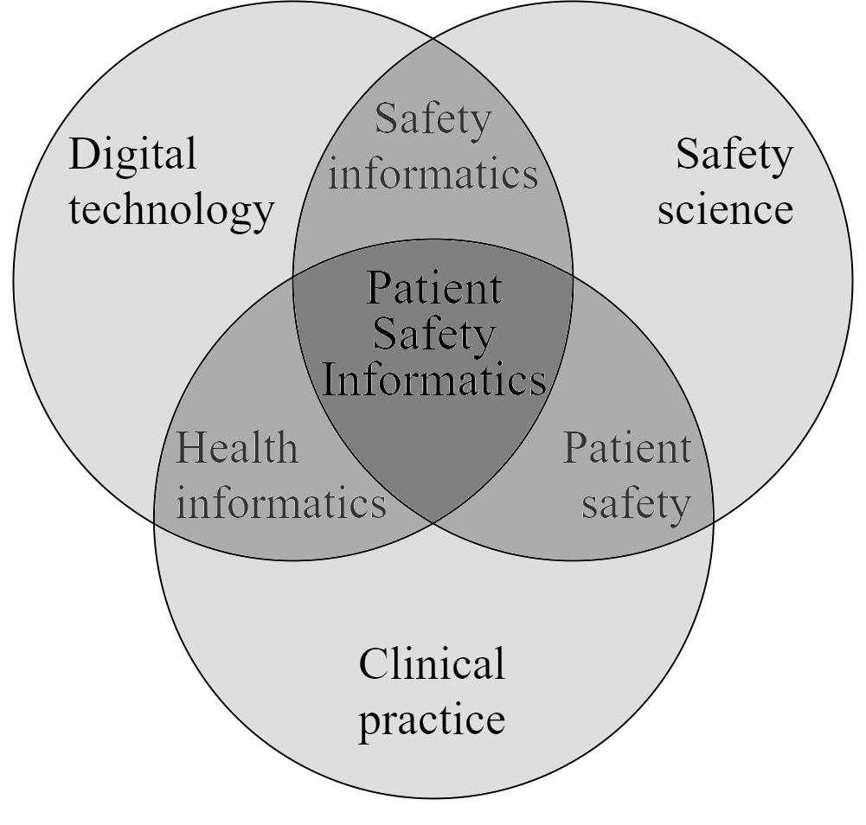

*Figure 1 – Our suggested definition of Patient Safety Informatics incorporates elements of digital technology, safety science and clinical care.*

Discussion

Patient safety and its relationship with digital health

Patient safety can be variously defined as the “avoidance, prevention and amelioration of adverse outcomes or injuries stemming from the process of healthcare”[33] or “the reduction of risk of unnecessary harm associated with healthcare to an acceptable minimum”[27]. It is sometimes conceptualised as a balance between risks of harm, resource use, and improving patient health[7]. Health care is a safety-critical industry[31] that must approach safety by concurrently avoiding, managing and embracing risk[34]. This sets health care apart from other safety-critical industries – like aviation and offshore oil production – that predominantly focus on only one of these approaches[34].

While the patient-safety perspective on digital health technology is not novel[17], the types of patient-safety challenges and our capacity to address them are constantly in flux. Policy, standards and regulations specific to digital health technology are being drafted worldwide[13] to keep pace with evolving health care, including the US Food and Drug Administration, and the UK’s National Health Service and the National Institute for Health and Care Excellence[21,22,32]. Digital health information technologies are becoming increasingly networked in line with the fourth industrial revolution, posing novel safety issues as technologies interact[40]. This is because when health information technologies interact, they form a health information system[23], or what some have referred to as information infrastructures[1], the success or failure of which is partly due to emergent rather than planned change resulting from local improvisation[10]. These health information systems are the inevitable structure of how digital health is evolving[2,8], and will require a systemic perspective from developers, users and patient-safety researchers to mitigate emergent challenges to patient safety.

Markus[19] provides a framework to map the ways that digital health could evolve. Markus[19] implies a 2x2 model describing the risks associated with both novel and existing technologies and their application (Figure 2). Technochange refers to the highest-risk of combining novel applications of new technologies. This high-risk path for digital health is driven by the relationship between vendors who want to be first to market and buyers who want to be seen to innovate. These incentives can encourage high risks for associated large rewards. It is important to note that health information systems are complex adaptive systems[15] embedded within health care – itself a complex adaptive system. Whether technology is introduced via familiar or novel applications, it is likely to have unforeseeable consequences.

|  |  |  |
| --- | --- | --- |
|  | *New technology* | *Existing technology* |
| *Novel application* | High risk | Moderate risk |
| *Familiar application* | Moderate risk | Low risk |

*Figure 2 – Contingency table illustrating the risk categories associated with interactions of novel and existing technology and its application. Adapted from Markus*[19]*.*

Whether digital health evolves along Markus’s high, moderate or low risk paths, many challenges posed by increasingly-complex digital health are similar[24]: innovations are unlikely to be equally affordable and available for all[4]; algorithms and models are of transient relevance[14]; there has been a continued lack of sufficient testing, despite early calls[18]; societal challenges like an aging population[25]; and legal and political jurisdiction[39]. Each of these challenges are associated with known and unknown consequences for patient safety, which need to be addressed for responsible provision of health care. Hence, there is a need for rigorous study of the relationship between emerging digital health and patient safety – that is to say, a Patient Safety Informatics.

Toward a definition of Patient Safety Informatics

Informatics is the interdisciplinary study of information and its environment[9]. Crucially, information flow is recognised as a key component of system safety and is a reflection of safety culture[37]. This understanding has led to the relatively new concept of Safety Informatics, defined as the scientific discipline studying safety information and its mechanisms, to address the lack of safety information in safety management[35]. For Wang and colleagues who proposed this definition, safety information refers to safety-related data that shows systems’ safety state and its changes[11,36]. Thus, our proposed definition of Patient Safety Informatics incorporates concern for the state and dynamics of patient-safety information.

Despite theoretical and practical progress in safety informatics, it has yet to be applied substantially to health care and patient safety. Bakken, Cimino and Hripcask[3] explored how informatics can promote patient safety and provided recommendations like integrating informatics into health care curricula and the evaluation of digital health from health-economic, clinical and administrative perspectives. While welcomed, these recommendations, and the challenges they purport to address, concern digital health technologies in isolation and their function in promoting patient safety, only. To address emerging digital health, Patient Safety Informatics must also consider the safety of health information systems and their safe use[28].

The consideration of health care information systems is central to our proposed definition of Patient Safety Informatics, in line with the International Medical Informatics Association working group on ‘Health Informatics for Patient Safety’. The working group consider their role as “[promoting] patient safety of health information systems and their associated medical devices [and focusing on] how healthcare information systems can improve patient safety, as well as identifying and rectifying safety issues”[12]. Patient Safety Informatics may therefore be considered to address both the questions of: 1) whether newly developed or adopted digital health technologies are inherently safe, and 2) how technologies can be designed and applied specifically to improve patient safety. This scope is exemplified in Singh and Sittig’s Health Information Technology Safety Measurement Framework, which defines three safety domains embedded in a sociotechnical work system: safe health information technology, safe use of health information technology, and using health information technology to improve safety[28].

Limitations

We recognise that our method was not a strict Delphi approach and would have benefited from a larger sample of expert participants. As stated from the outset, we intended this work to act a a starting point for defining and justifying Patient Safety Informatics as a distinct field.

Conclusions

The intention of this paper was to contribute to the process of developing the theoretical and practical foundations of Patient Safety Informatics, answering calls for practical progress in safety science[26]. The intersection between the established and broad disciplines of digital technology, safety science and clinical practice give rise to applied research and practice in health informatics, patient safety and safety information systems.

…These ideas will be further explored in subsequent workshops in our series that will address the consequences of contemporary safety theory for digital innovation, sociotechnical evaluation of digital health, and digital health interventions designed to improve patient safety.

Acknowledgements

This research is partly funded by the National Institute for Health Research (NIHR) Yorkshire and Humber Patient Safety Translational Research Centre (NIHR Yorkshire and Humber PSTRC). The views expressed in this paper are those of the authors and not necessarily those of the NHS, the NIHR, or the Department of Health and Social Care.

Authors have no conflicts of interest to declare. We would like to acknowledge the contribution of other workshop attendees to informing the content of this paper: Dr Sarah Darley, University of Manchester; Ms Yan Jia, University of York; Dr Aseem Mishra, University of Manchester; Mr Richard Dodd, University of Manchester.

References

[1] M. Aanestad, M. Grisot, O. Hanseth, and P. Vassilakopoulou, Information Infrastructures within European Health Care: Working with the Installed Base, Springer, 2017. doi:10.1007/978-3-319-51020-0.

[2] G. Aceto, V. Persico, and A. Pescapé, Industry 4.0 and Health: Internet of Things, Big Data, and Cloud Computing, *J. Ind. Inf. Integr.* **18** (2020) 100129. doi:10.1016/j.jii.2020.100129.

[3] S. Bakken, J.J. Cimino, and G. Hripcsak, Promoting patient safety and enabling evidence-based practice through informatics., *Med. Care*. **42** (2004) 49–56. doi:10.1097/01.mlr.0000109125.00113.f4.

[4] A. Banerjee, Digital health interventions and inequalities: The case for a new paradigm, *BMJ Evidence-Based Med.* **2** (2019) 2–5. doi:10.1136/bmjebm-2019-111282.

[5] H. Benbya, N. Nan, H. Tanriverdi, and Y. Yoo, Complexity and Information Systems Research in the Emerging Digital World, *Manag. Inf. Syst. Q.* **44** (2020) 1.

[6] P. Catherine, The Delphi technique: myths and realities., *J. Adv. Nurs.* **41** (2003) 376–382. http://www.embase.com/search/results?subaction=viewrecord&from=export&id=L36478234.

[7] R. Cook, and J. Rasmussen, “Going solid”: A model of system dynamics and consequences for patient safety, *Qual. Saf. Heal. Care*. **14** (2005) 130–134. doi:10.1136/qshc.2003.009530.

[8] B. Farahani, F. Firouzi, V. Chang, M. Badaroglu, N. Constant, and K. Mankodiya, Towards fog-driven IoT eHealth: Promises and challenges of IoT in medicine and healthcare, *Futur. Gener. Comput. Syst.* **78** (2018) 659–676. doi:10.1016/j.future.2017.04.036.

[9] J. Gammack, V. Hobbs, and D. Pigott, The Book of Informatics, Cengage Learning, 2011.

[10] R. Heeks, Health information systems: Failure, success and improvisation, *Int. J. Med. Inform.* **75** (2006) 125–137. doi:10.1016/j.ijmedinf.2005.07.024.

[11] L. Huang, C. Wu, B. Wang, and Q. Ouyang, A New Paradigm for Accident Investigation and Analysis in the Era of Big Data, *Process Saf. Prog.* **37** (2017) 42–48. doi:10.1002/prs.11898.

[12] IMIA WG7, WG7 - Working Group on Health Informatics for Patient Safety, (2018). https://imia-medinfo.org/wp/health-informatics-for-patient-safety/.

[13] International Comparative Legal Guide, Digital Health Laws and Regulations 2020, Global Legal Group, 2020. https://iclg.com/practice-areas/digital-health-laws-and-regulations/usa.

[14] D.A. Jenkins, M. Sperrin, G.P. Martin, and N. Peek, Dynamic models to predict health outcomes: current status and methodological challenges, *Diagnostic Progn. Res.* **2** (2018) 1–9. doi:10.1186/s41512-018-0045-2.

[15] O.A. Johnson, General System Theory and the Use of Process Mining to Improve Care Pathways, in: P. Scott, N.F. de Keizer, and A. Georgiou (Eds.), Appl. Interdiscip. Theory Heal. Informatics A Knowl. Base Pract., IOS Press, 2019: pp. 11–22. doi:10.3233/SHTI1263.

[16] M.O. Kim, E. Coiera, and F. Magrabi, Problems with health information technology and their effects on care delivery and patient outcomes: a systematic review, *J. Am. Med. Informatics Assoc.* **24** (2017) 246–260. doi:10.1093/jamia/ocw154.

[17] P. Kostkova, Grand challenges in digital health, *Front. Public Heal.* **3** (2015) 1–5. doi:10.3389/fpubh.2015.00134.

[18] N.G. Leveson, Software Safety: Why, What, and How, *Comput. Surv.* **18** (1986).

[19] M.L. Markus, Technochange management: Using IT to drive organizational change, *J. Inf. Technol.* **19** (2004) 4–20. doi:10.1057/palgrave.jit.2000002.

[20] National Institute for Health Research, £17 million invested in NIHR Patient Safety Translational Research Centres, (2017). https://www.nihr.ac.uk/news/17-million-invested-in-nihr-patient-safety-translational-research-centres/12278 (accessed March 26, 2021).

[21] NHS, The NHS Patient Safety Strategy: Safer culture, safer systems, safer patients, (2019). https://improvement.nhs.uk/resources/patient-safety-strategy/.

[22] NICE, Evidence standards framework for digital health technologies: User guide, (2019). https://www.nice.org.uk/about/what-we-do/our-programmes/evidence-standards-framework-for-digital-health-technologies.

[23] M.F.A. Onik, E. Fielt, and G.G. Gable, Complex Adaptive Systems Theory in Information Systems Research - A Systematic Literature Review, in: S.C. Ling, S. Bahri, and P. Finnegan (Eds.), Pacific Asia Conf. Inf. Syst., 2017: pp. 1–14. https://eprints.qut.edu.au/111589/1/pacis - 2017 - Complex Adaptive Systems Theory in Information Systems Research - A Systematic Literature Review.pdf.

[24] N. Parvizi, and K. Woods, Regulation of medicines and medical devices: Contrasts and similarities, *Clin. Med. J. R. Coll. Physicians London*. **14** (2014) 6–12. doi:10.7861/clinmedicine.14-1-6.

[25] A. Pilotto, R. Boi, and J. Petermans, Technology in geriatrics, *Age Ageing*. **47** (2018) 771–774. doi:10.1093/ageing/afy026.

[26] A. Rae, D. Provan, H. Aboelssaad, and R. Alexander, A manifesto for Reality-based Safety Science, *Saf. Sci.* **126** (2020). doi:10.1016/j.ssci.2020.104654.

[27] W. Runciman, P. Hibbert, R. Thomson, T. Van Der Schaaf, H. Sherman, and P. Lewalle, Towards an International Classification for Patient Safety: Key concepts and terms, *Int. J. Qual. Heal. Care*. **21** (2009) 18–26. doi:10.1093/intqhc/mzn057.

[28] H. Singh, and D.F. Sittig, Measuring and improving patient safety through health information technology: The health IT safety framework, *BMJ Qual. Saf.* **25** (2016) 226–232. doi:10.1136/bmjqs-2015-004486.

[29] D.F. Sittig, A. Wright, E. Coiera, F. Magrabi, R. Ratwani, D.W. Bates, and H. Singh, Current challenges in health information technology–related patient safety, *Health Informatics J.* **26** (2020) 181–189. doi:10.1177/1460458218814893.

[30] D.F. Sittig, A. Wright, E. Coiera, F. Magrabi, R. Ratwant, D.W. Bates, and H. Singh, Current challenges in health information technology–related patient safety, *Health Informatics J.* (2018) 1–9. doi:10.1177/1460458218814893.

[31] M.A. Sujan, I. Habli, T.P. Kelly, S. Pozzi, and C.W. Johnson, Should healthcare providers do safety cases? Lessons from a cross-industry review of safety case practices, *Saf. Sci.* **84** (2016) 181–189. doi:10.1016/j.ssci.2015.12.021.

[32] US Food and Drug Administration, Digital Health Innovation Action Plan, (2017). https://www.fda.gov/media/106331/download.

[33] C. Vincent, Patient Safety, 2nd ed., Wiley-Blackwell, Oxford, 2010.

[34] C. Vincent, and R. Amalberti, Approaches to Safety: One Size Does Not Fit All, in: Safer Healthc. Strateg. Real World, Springer, 2016: pp. 27–38. doi:10.1007/978-3-319-25559-0.

[35] B. Wang, and C. Wu, Safety informatics as a new, promising and sustainable area of safety science in the information age, *J. Clean. Prod.* **252** (2020) 119852. doi:10.1016/j.jclepro.2019.119852.

[36] B. Wang, and C. Wu, The outline of safety informatics, *J. Intell.* **37** (2018) 88e96.

[37] R. Westrum, The study of information flow: A personal journey, *Saf. Sci.* **67** (2014) 58–63. doi:10.1016/j.ssci.2014.01.009.

[38] J. Wherton, S. Shaw, C. Papoutsi, L. Seuren, and T. Greenhalgh, Guidance on the introduction and use of video consultations during COVID-19: important lessons from qualitative research, *BMJ Lead.* (2020). doi:10.1136/leader-2020-000262.

[39] M. Wismar, W. Palm, J. Figueras, K. Ernst, and E. van Ginneken, Cross-border Health Care in the European Union: Mapping and analysing practices and policies, WHO Europe;, Copenhagen, 2011. https://apps.who.int/iris/bitstream/handle/10665/327961/9789289002219-eng.pdf.

[40] N. Wickramasinghe, and F. Bodendorf, eds., Delivering Superior Health and Wellness Management with IoT and Analytics, Springer, 2020. doi:10.1007/978-3-030-17347-0.

**Address for correspondence**

Ciarán McInerney, [c.mcinerney@leeds.ac.uk](mailto:c.mcinerney@leeds.ac.uk)

Table 2– Summary of recommendation to address safety concerns posed by the challenges of emerging digital health. P = practical applications; T = theory development

|  |  |  |
| --- | --- | --- |
| **Challenge** | **Consequence** | **Recommendation** |
| Difficult to conceptualise threats to patient safety from non-physical innovations | Inadequate consideration of threats to patient safety | Systems approach to conceptualising riskT; Safety casesP; Sociotechnical perspective |
| Unclear how to sensibly integrate and interpret new and voluminous data streams | Missed opportunity to use data; Inappropriate use of data; Biased use of data | Dynamic and causal modelling continuously surveilled for performanceP; Middleware for interoperabilityP; Standards for linkage and exchange of health care dataP; Automated anolaly detectionP |
| Reactive regulatory- and standards-based approaches to safety | Avoidable hearm is experienced before mitigations are put in place | Gradual approval of medical devicesP; Systems approach to conceptualising riskT |
| Difficult to build and maintain trust in health informatio sytems that are obscure and complex | Misinformation and disinformation threaten patient safety | Sociotechnical perspectiveT; FactSheetsP |
| Emergent patient-safety consequences in health information systems | Hazards cannot be completely foreseen | Systems approach to conceptualising riskT; Systems approach to patient safetyT; Safety casesP; Sociotechnical perspectivesT; Gradual approval of medical devicesP |
| Solutionism inappropriately simplifies provlems and predicaments | Unfit interventions and assurances | Sociotechnical perspectiveT; Systems approach to conceptualising riskT |